Modelling and Output-Feedback Control of a Planar Vectored-Thrust VTOL Aircraft
Nigel Grommen, N11908203
Abstract—This paper presents the modelling and output-feedback control of a planar vectored-thrust VTOL aircraft. A nonlinear model is derived from first principles and linearised at hover equilibrium, revealing an underactuated horizontal channel, only controllable through the aircraft's roll dynamics. An optimal LQR state-feedback controller with integral action is designed on this model and combined with a Luenberger observer to reconstruct the unmeasured velocity states, forming a complete output-feedback system evaluated on a nonlinear black-box plant. The controller drives the aircraft to the target position, rejects horizontal disturbances without steady-state bias, and remains within actuator limits, with robustness confirmed across multiple disturbances and initial conditions. The results show the directly actuated vertical channel settles rapidly while the underactuated horizontal channel is inherently slower showcasing a fundamental limitation of the platform rather than the controller design itself.

INTRODUCTION
Vertical take-off and landing (VTOL) aircraft have established themselves as a versatile platform for both manned and unmanned aerial vehicles [1]. This platform combines the efficiency of long-distance high-speed flight and the operational capability in tight spaces without the need for dedicated runways [2] [3]. Due to lack of dependency on airport/airfields, these platforms have seen increased use for both military and civil sectors for applications such as earthquake relief, ground traffic pressure and so on [1]. However, the aerodynamic and mechanical properties that give VTOL aircraft their operational flexibility also make them significantly harder to control than conventional aircraft platforms. A VTOL system must operate across multiple distinct flight regimes. They must vertically hover, transition, and cruise, each governed by fundamentally different aerodynamic behaviours [2]. This report addresses the modelling and automatic control of a scaled planar VTOL aircraft operating under vectored thrust in two-dimensional flight. A mathematical model of the system is derived from first principles and linearised at an equilibrium hover condition. Using this model, a state-feedback controller is synthesised via LQR/Optimal gain design and a Leuenberger observer is created to reconstruct the unmeasured states from the available output measurements. The combined output-feedback control system is then implemented and evaluated. The remainder of this report is organised as follows. Section 2 presents the mathematical model of the VTOL system, Section 3 describes the controller, observer, and output-feedback control system design, Section 4 presents the simulation results and analysis and Section 5 concludes the report.

Mathematical Model
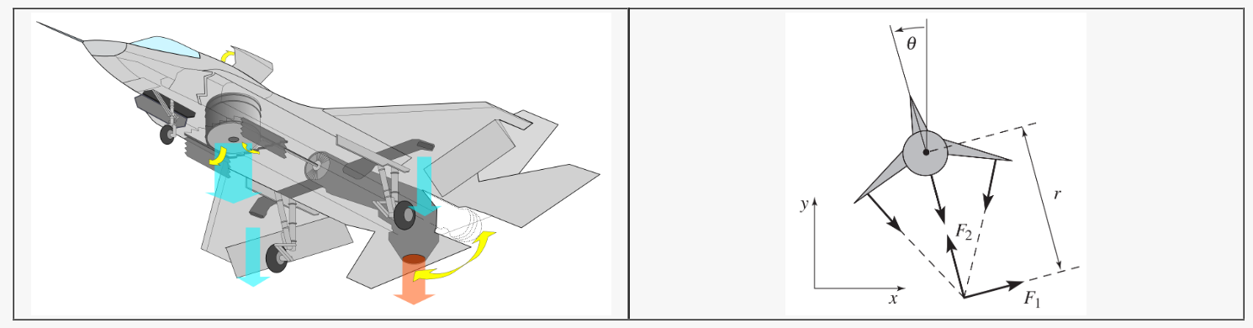
Fig. 1. System configuration of the planar vectored-thrust VTOL aircraft. Source: [4].
The 2D VTOL model is constrained to motion in only the vertical and horizontal planes and is controlled via two forces, a lateral force $F_{1}$ and a thrust force $F_{2 }$ applied at a distance r below the centre mass. The model contains three measurable outputs which include the roll angle $θ$ and model positions x, y, see Fig. 1. The control objective is to drive the aircraft from origin (0,0) to a target equilibrium of (x, y) = (3, 3) m.

Modelling Assumptions
Several assumptions are used to simplify the derivation process for a manageable mathematical model appropriate for linear control design. First the aircraft is treated as a rigid body, structural flexibility and any deformation of the airframe under load are neglected. Second, the aircraft is constrained to a two-dimensional plane with three degrees of freedom, horizontal position x, vertical position y and roll angle $θ$. Third, aerodynamic drag is modelled as linear viscous damping c, acting on the translational dynamics only, appearing as a damping force proportional to the horizontal and vertical velocities $\ddot{x}$ and $\ddot{y}$ respectively. All other aerodynamic effects such as lift generated from the airframe and drag during transitional movements are neglected. Fourth, the two control forces are treated as direct control inputs for the system and are assumed to act at a fixed distance r below the centre of mass of the aircraft. This is to neglect actuator dynamics and keep the model tractable for linear control design, however hard actuator limits of $F_{1 }ϵ$ [-40, 40] and $F_{2 }ϵ$ [0, 80] are enforced in the implementation to act as realistic motor constraints. Lastly, complex atmospheric conditions and turbulence are not captured in the model, however an external force disturbance acting in the horizontal direction is introduced during simulations to evaluate the robustness of the control system against conditions representative of wind loading.

Nonlinear Equations of Motion
The nonlinear equations of motion that describe the planar movement of the VTOL aircraft are derived from Newton-Euler mechanics, describing the translational and rotational dynamics of the system, which are governed by [4]:

$$m\ddot{x}=F_{1}\cos{θ}-F_{2 }\sin{θ- }c\dot{x}$$

$$m\ddot{y}= F_{1 }\sin{θ}+ F_{2}\cos{θ}-mg-c\dot{y}$$ | (1)
$$J\ddot{θ}=rF_{1}$$

The system state is defined as $x={\left[x \dot{x} y \dot{y} θ \dot{θ }\right]}^{T}$ comprising of the horizontal and vertical positions, velocities and the roll angle and angular rate. For linearisation the control inputs are $u_{1}= F_{1}$ and $u_{2}= F_{2}-mg$ [4]. See table 1 for notation summary and numerical values of the system parameters used throughout the report and the simulations.

Table 1. Notation & System Parameters table
Symbol | Description | Value | Unit
m | Aircraft mass | 4 | $$kg$$
J | Moment of inertia | 0.0475 | $$kg∙m^{2}$$
r | Thrust offset distance | 0.25 | $$m$$
g | Gravitational constant | 9.81 | $$m∙s^{-2}$$
c | Damping coefficient | 0.05 | $$N∙s∙m^{-1}$$
x | Horizontal position | - | $$m$$
y | Vertical position | - | $$m$$
$$θ$$ | Roll angle | - | $$rad$$
$$F_{1}$$ | Lateral force | - | $$N$$
$$F_{2}$$ | Thrust force | - | $$N$$

The three equations (1) form a coupled nonlinear system, where positional dynamics in x and y are dependent on the roll angle $θ$, through trigonometric terms cos and sin. Only the lateral force $F_{1}$ operating through the movement arm r below the centre of mass, drive the rotational dynamics. Notably $F_{2}$ produces no rotational moment, as it does not appear in the equation. This coupling between rotational and translational dynamics, combined with trigonometric terms, makes direct control design impracticable.

Linearisation
The nonlinear dynamics (1) are linearised about the hover equilibrium to obtain a model suitable for linear control design. At hover the aircraft is stationary and level, so all velocities, accelerations, and the roll angle become zero. To achieve these conditions the required vertical thrust must counteract gravity without assistance from lateral forces, resulting in $F_{2}$ = mg, and $F_{1}$ = 0, corresponding to an equilibrium input $\overline{u}={[0, 0]}^{T}$and equilibrium state at the target position $\overline{x}={[3, 0, 3, 0, 0, 0]}^{T}$. Linearising the dynamics $\dot{x}=f(x, u)$ at this equilibrium condition yields $δ\dot{x}=Aδx+Bδu$where deviation coordinates $δx= x- \overline{x}$ and $δu= u- \overline{u}$, which are state and input deviations from equilibrium, where A and B are the Jacobians of the dynamics evaluated at the equilibrium point, represented as:

$$A=\left[\begin{matrix}0 & 1 & 0 & 0 & 0 & 0 \\ 0 & -\frac{c}{m} & 0 & 0 & -g & 0 \\ 0 & 0 & 0 & 1 & 0 & 0 \\ 0 & 0 & 0 & -\frac{c}{m} & 0 & 0 \\ 0 & 0 & 0 & 0 & 0 & 1 \\ 0 & 0 & 0 & 0 & 0 & 0\end{matrix}\right]$$ | $$B=\left[\begin{matrix}0 & 0 \\ \frac{1}{m} & 0 \\ 0 & 0 \\ 0 & \frac{1}{m} \\ 0 & 0 \\ \frac{r}{J} & 0\end{matrix}\right]$$ | (2)
At hover equilibrium, trigonometric terms such as sin and cos are approximated to 0 and 1 respectively, eliminating rotational-translation coupling between the inputs. The horizontal motion, however, remains coupled to the roll angle through the gravity term −g even after linearisation, meaning the aircraft can only accelerate horizontally by tilting the airframe. Consequently, the linearised model is valid only for small deviations from equilibrium, with accuracy degrading as the roll angle and velocities grow, a limitation the closed-loop controller mitigates by regulating the system back toward the operating point.

State Space Model
The linearised model (2) demonstrates the aircraft’s behaviour near hover. The six states separate into three groups. Vertical movement is driven directly by thrust and is not coupled to any other states. The roll is only driven by lateral force as its row in matrix A contains no other restoration or damping terms, resulting in the inability for the aircraft to level on its own accord. Horizontal movement, however, is coupled with tilt via the -g term in matrix A. The aircraft has no direct horizontal input and only generates motion in this plane by first tilting, so the thrust gains a horizontal component. The lateral force is the only control that tilts the aircraft, and tilting is the only way to produce sideways motion. A single input therefore governs both the roll and the horizontal motion, leaving the system underactuated in the horizontal plane.

Control System Design
Without active control, the current open-loop system cannot reject horizontal force disturbances that drive the horizontal channel away from equilibrium. A closed-loop controller is therefore required to stabilise the system, track the target position, and reject disturbances while respecting actuator limits.
Control is implemented in discrete time, the continuous model is discretised using a zero-order hold at a sampling period of $T_{s}$ = 0.01 s, giving the discrete-time state and input matrices G and H, which are used for the controller design.

Controllability & LQR
The discretised system is full rank, allowing its closed-loop poles to be assigned by state feedback. An optimal linear-quadratic regulator (LQR) is chosen over direct pole placement methodology as it provides a systematic way to handle the coupled, multi-input dynamics, where suitable individual pole locations are not distinctly obvious. Rather than specifying poles directly, LQR computes the feedback gain that minimises the quadratic cost represented as:

$$J=\sum_{k=0}^{∞}{\left(δx_{k}^{T}Q δx_{k}+u_{k}^{T}R u_{k}\right)}$$ | (3)

where the weighting matrices Q and R penalise state deviation and control effort respectively. The relative magnitude between Q and R determines the controller balance between regulation aggressiveness and economical actuator use. The selected weighting matrices are Q = diag(200, 300, 50, 50, 400, 250) and R = 5I.
The roll angle is given the largest state weight because roll stability is critical, an improperly regulated tilt will destabilise the entire system causing severe diverging oscillations. This is because the horizontal channel depends heavily on roll angle, as horizontal movement is only possible by tilting. Horizontal position and velocity are also weighted heavily to hold the horizontal channel steady and recover quickly from disturbances. The relative weighting of horizontal position and velocity shapes the transient response, trading settling time against overshoot. The vertical states, by contrast, are weighted far more lightly, as the vertical channel is directly actuated and self-damping, achieving clean, well-regulated tracking without aggressive weighting. Control-effort weighting R balances the state regulation against actuator usage. A lightweight R produced a fast but overly aggressive response that drove the forces into their saturation limits. On the other hand, an excessive control penalty slows the response, Therefore, weighting was increased until the response remained smooth and the actuator forces stayed within assumed motor constraints. The final weights were obtained by iterative tuning within this structure, trading a fast, well-damped response against the requirement to respect the actuator limits while converging reliably to the target. The resulting closed-loop poles lie within the unit circle, confirming the discrete closed-loop system is stable.

Integral Action
Under constant disturbances a steady-state error is present. Integral action removes this by accumulating the position error and driving it to zero. The integrator state accumulates the error at each step and is combined with the state feedback in the control law represented as:

$$u_{k}=u_{eq}-K_{d}{\hat{x}}_{k}-K_{i}z_{k}$$ | (4)

Where ${\hat{x}}_{k}$is the estimated state deviation, $z_{k}$ the integrator state, $K_{d}$ the feedback gain, $K_{i}$ the integral gain and $u_{eq}$ the equilibrium (hover) input. The feedback and integral gains are obtained by applying the same iterative method to the augmented system with the integrator states. However, integrating throughout the large initial approach to the target would cause the accumulator to grow far beyond what is needed, producing severe overshoot as it later unwinds. Two measures are implemented to prevent this. First, integration is only applied when the tracking error is under a small threshold. Meaning, when the aircraft is far from the target the accumulator is instead decayed, allowing the integral action to be engaged for fine steady-state correction rather than during the initial transient response. The vertical channel integrates from a wider error band in comparison to the horizontal channel, as it requires more integral authority to hold against the constant disturbance, whereas the horizontal channel restricts integration more tightly to avoid windup during its larger approach. Second, the integrator state is clamped so that its contribution to the control force cannot exceed a fixed control budget, set below the actuator limit, reserving the remaining capacity for the feedback term and preventing the integrator from dominating the command.

Luenberger observer
The state-feedback law requires the full state to operate, but only the positions and roll angle measurements are available, due to sensor limitations, leaving three velocity states unavailable. A Luenberger observer is therefore required and designed to reconstruct the full states from the available measured outputs. The system is first confirmed observable, guaranteeing that an observer gain exists which drives the estimation error to zero. The observer poles are chosen by reflecting the controller poles to be approximately ten times faster, so that the estimation error decays quicker than the controlled dynamics. This ensures the observer converges before its error can meaningfully affect the control loop, allowing the controller and observer to be designed separately under the separation principle. However, there is a deliberate trade off with this speed, a faster observer rejects estimation error more quickly but places greater weight on the measurements, making it more sensitive to measurement noise, a limitation that is examined as an extension in Section IV. The observer runs in a predictor–corrector form, propagating the estimate through the model and correcting it in proportion to the difference between the measured and predicted outputs.

Results and Analysis
The complete output-feedback controller, combined with the Luenberger observer, optimal state feedback, and integral action, is now evaluated on the nonlinear black-box system. This is because the black box differs from the nominal model through parameter uncertainty, input disturbances, and measurement noise. Successful regulation of the system under these conditions demonstrates that the controller, designed only on the linearised model, generalises to the full nonlinear dynamics.

Tracking and Model Validation
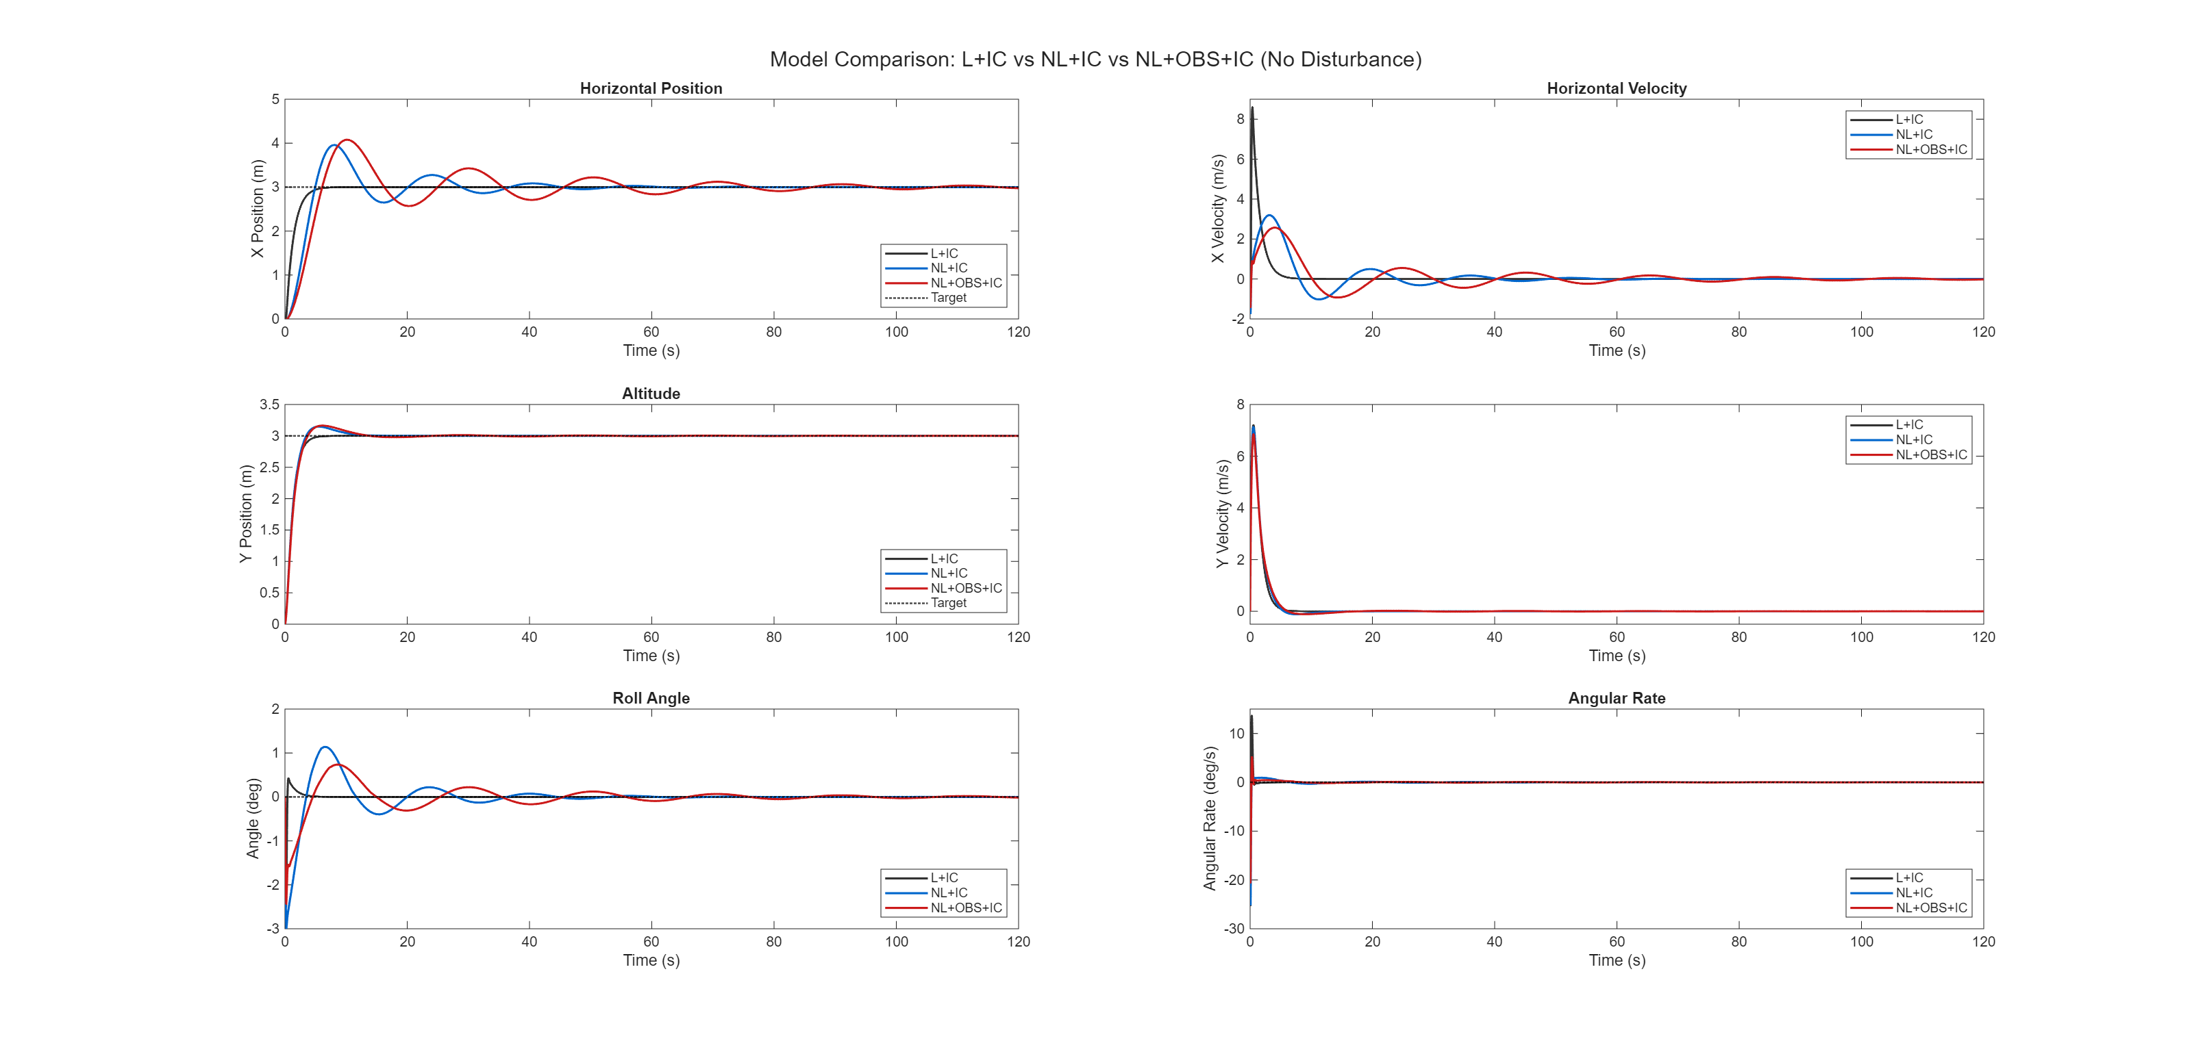
Fig. 2. Closed-loop controller responses of the linearised model under full state feedback (L+IC), the nonlinear model under full-state feedback (NL+IC), and observer-based output feedback model (NL+OBS+IC), all without disturbance, showing close agreement across all three traces.
Fig. 2 compares the linearised closed-loop response with the nonlinear responses under full-state output feedback and observer-based output feedback, all without disturbance. Under all three conditions, the controller successfully drives the aircraft from origin to the target position of (3,3) m, confirming that the controller stabilises and tracks on the nonlinear system.
The altitude settles rapidly with little overshoot, peaking at 3.16 m (5.5% overshoot) and settling within 10.71 s, whereas the horizontal channel is noticeably slower and more oscillatory, peaking at 4.08 m (35.9% overshoot) and settling only after 92.56s. This disparity is due to the system structure. Altitude is directly actuated by the thrust and responds immediately, while horizontal motion is underactuated and can only be produced by first tilting the aircraft, so the larger overshoot and slower settling reflect the indirect path through the roll dynamics rather than any deficiency in the controller performance.
The similar trajectories between the linearised and nonlinear responses confirms that the linearisation is valid for controller design, and demonstrates a controller created on the linear model, successfully regulates the nonlinear plant because it holds the roll angle and velocities small throughout, keeping the system within the region where the linear approximation is valid. The observer-based response closely follows the full-state response, offset only by a small lag as the observer converges its estimate from the measured outputs, showcasing the inherent cost of reconstructing the unmeasured states rather than measuring them directly. This confirms the reconstructed states are sufficient for control, and that the complete output-feedback system performs on the nonlinear plant as the full-state design intended.
The roll-angle, horizontal-velocity, and horizontal-position traces together confirm the coupling predicted by the model. The aircraft first develops a roll angle, which redirects the thrust to produce a horizontal component that accelerates the aircraft, building horizontal velocity, which in turn carries the aircraft toward the horizontal target position. The roll therefore leads the velocity, and the velocity leads the position, confirming that horizontal motion is only achieved through tilt rather than by direct horizontal actuation.

Actuator Limits
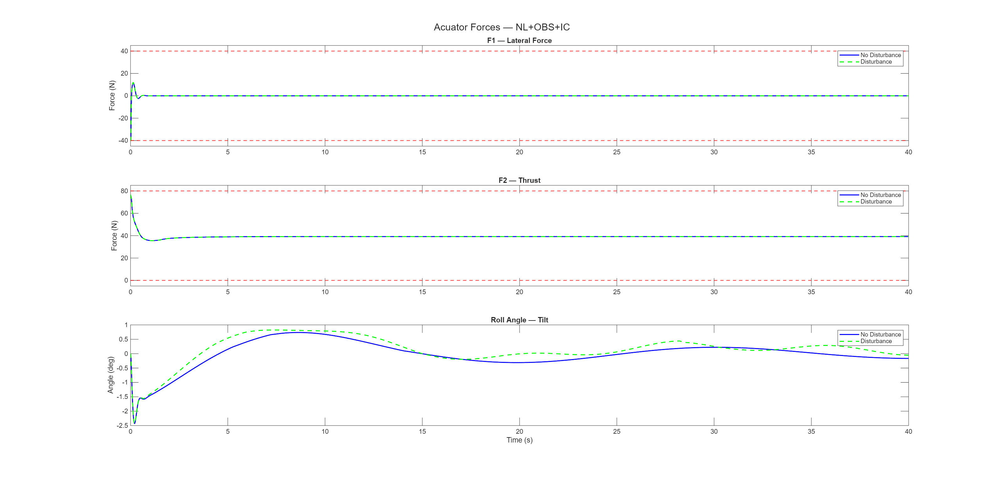
Fig. 3. Actuator forces F₁ (lateral) and F₂ (thrust) shown against their limits of $±$40 N and 0–80 N, with the corresponding roll angle, under observer-based output feedback with and without disturbance over the first 40s of the simulation time.
The actuator forces respect their limits throughout, as shown in Fig. 3 and confirmed by the compliance software check. At initial startup, both actuators operate at or near their limits, lateral force $F_{1}$ saturates at its −40 N limit and the thrust $F_{2}$ peaks at 76.4 N, just below the 80 N ceiling. These forces during initial startup are expected, as the aircraft is the furthest from the target, forcing the controller to command maximum effort to initiate the climb. After this initial transient response both forces settle rapidly. $F_{1}$ returns to a near-zero average of 0.05 N and vertical thrust $F_{2}$ to 39.25 N, balancing the aircraft weight.
High actuator effort is confined to the brief initial manoeuvre, while steady-state operation is economical. The brief lateral force $F_{1}$ saturation explains why the horizontal response is slow to settle. Since the lateral force is already at its maximum during startup, the controller is using all the authority available to it. The slow horizontal settling is therefore a fundamental limit of the underactuated aircraft, which must tilt to create horizontal motion, rather than a result of cautious tuning. The roll-angle trace confirms this horizontal coupling from the input side. The lateral force tilts the aircraft, and the tilt redirects the thrust to give it a horizontal component, resulting in horizontal aircraft motion.

Disturbance Rejection Performance
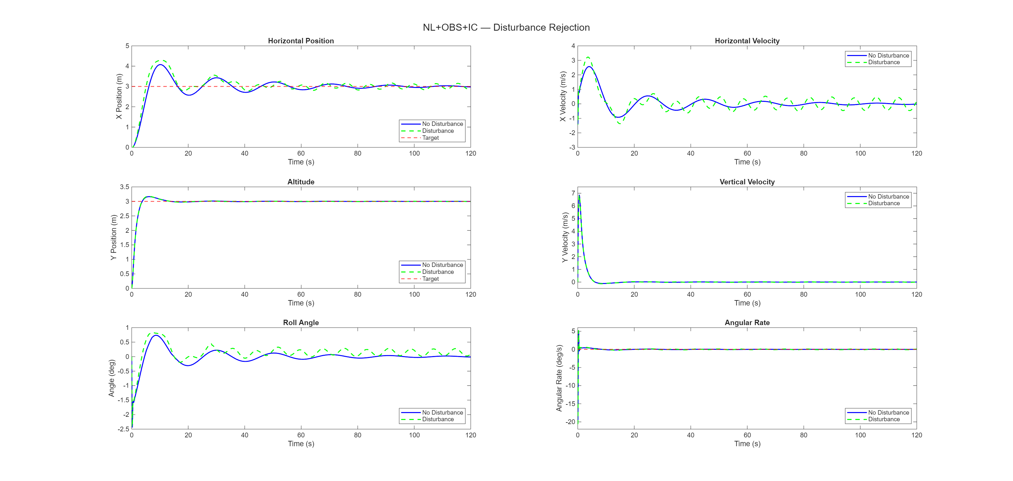
Fig. 4. Output-feedback response of the observer-based system, with and without a simulated horizontal force disturbance.
Fig. 4 Demonstrates the output-feedback response of the observer-based system with and without, horizontal disturbances introduced into the system, to mimic wind loading. For both disturbances cases the altitude converges to equilibrium within 10.7 s, and 5.5% overshoot. However, the horizontal channel is affected by this disturbance, causing an increase in peak overshoot from 35.9% to 43.1% with a peak at 4.29m, and sustains a low oscillation that does not settle within the 120s simulation. The Horizontal velocity trace showcases the integral action in effect, continuously working against the persistent disturbance, where position oscillates about the target on average. The roll-angle trajectory reveals how the disturbance is rejected, with no direct horizontal actuator, the only way to oppose a horizontal force is to tilt and generate a counteracting horizontal thrust component, Meaning the additional roll activity under disturbance is not a fault, but the physical limitation of the underactuated system actively rejecting it, causing the larger horizontal transient response. This showcases that the design can reject realistic horizontal disturbances representative of wind loading, while also exposing the inherent performance limitations of the underactuated horizontal channel.

Robustness
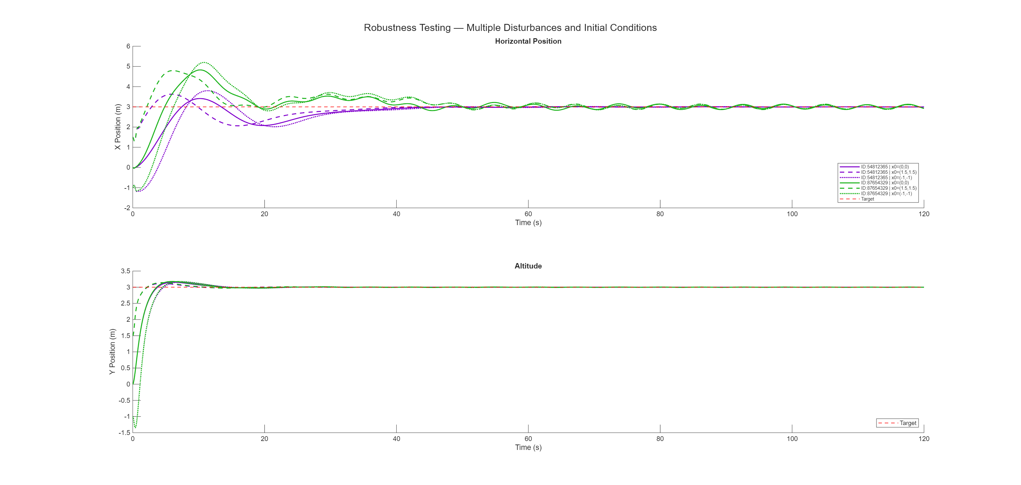
Fig. 5. Output-feedback response of the observer-based system, with different simulated horizontal force disturbances and starting positions.
To test controller robustness, the controller was simulated with two different disturbance profiles, each at three different initial positions, including at origin (0, 0), above origin (1.5, 1.5) and below origin (-1, -1), showcasing controller performance over a range of operating conditions. The altitude response is tight and nearly identical across all runs, reflecting the directly actuated vertical channel's insensitivity to horizontal disturbances and initial offsets.
The horizontal response, however, shows a greater variation in aircraft trajectories. The different initial conditions and disturbance profiles produce different peak overshoots and transient paths, but still converge or oscillate around the target, further confirming that the integral action drives the horizontal position to the reference regardless of the disturbance acting on the system. This consistency across operating conditions indicates the design is robust to the variations representative of real flight, where wind loading and launch states differ from the nominal case.

Extension – Kalman Filter
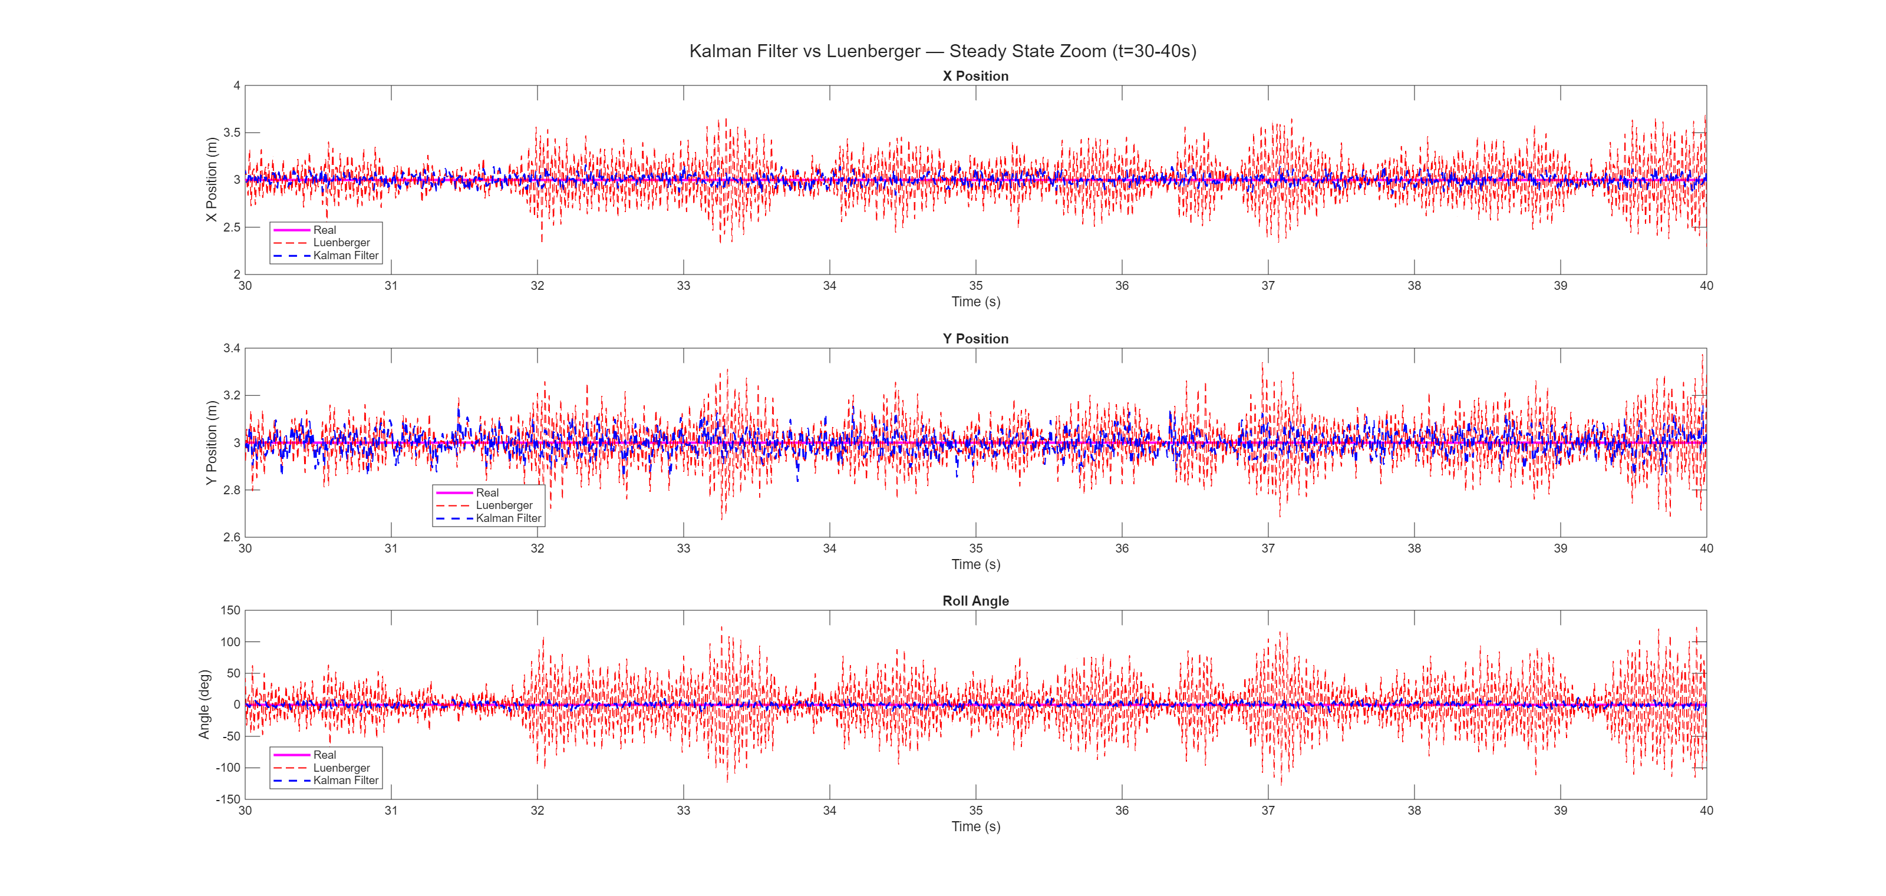
Fig. 6. Steady-state state estimates under injected Gaussian measurement noise, comparing the Luenberger observer and Kalman filter against the true state, on the linearised closed-loop model.
The high Luenberger observer gain, chosen for fast convergence, makes the observer more sensitive to measurement noise. This is not significant for the nominal black-box system but is examined here as an extension to see how the design would behave under noisy sensors. The final design retains the Luenberger observer and the Kalman filter is only explored to assess the benefit an optimal estimator would offer if measurement noise was present.
The comparison is performed on the linearised closed-loop model with injected Gaussian noise rather than the black box, isolating the estimators' response to noise. Fig. 6 shows the steady-state estimates under noise showcasing that the Luenberger estimate is heavily corrupted, while the Kalman estimate remains close to the true state across all channels. This demonstrates that the fixed-gain Luenberger observer severely amplifies measurement noise, whereas the Kalman filter suppresses it by weighting the noisy measurements appropriately. The Luenberger observer is sufficient for the nominal system, as analysed in previous sections but a Kalman filter would be the preferable estimator if the aircraft faced significant sensor noise. Reminder, this remains an exploratory extension, the final output-feedback design retains the Luenberger observer.

Conclusion
This report presented the modelling, control, and state estimation of a planar vectored-thrust VTOL aircraft. A nonlinear model was derived and linearised about the hover equilibrium, revealing an underactuated horizontal channel that can be controlled only through the roll dynamics of the system. An optimal LQR state-feedback controller with integral action was designed on this model and combined with a Luenberger observer to form a complete output-feedback system, which was then evaluated on the nonlinear black-box. The controller successfully stabilised and tracked the target position, rejected horizontal disturbances with no steady-state bias, and remained within the actuator limits, over a range of operating conditions. The main performance limitation is the slow, oscillatory horizontal response. This comes from the aircraft's under actuation in the horizontal channel as the aircraft must tilt to create horizontal motion. A Kalman filter extension further showed that an optimal estimator would be preferable should the system encounter significant measurement noise.

Future Work
Several improvements could follow from the limitations found in this work. First, the controller was evaluated against various disturbance profiles and initial conditions, but not against parameter variation. Since the thrust already operates near its 80 N limit at the nominal mass, a heavier aircraft would likely saturate the vertical actuator. Justifying the need for future work to test sensitivity to mass, inertia, and damping to identify the point at which the available actuator authority becomes insufficient. Lastly, the Kalman filter was evaluated only as an extension on the linearised model, integrating this into the output-feedback loop on the black-box system would provide optimal state estimation to increase the robustness of the system to combat real measurement noise.

References
- Y. Zhou, H. Zhao, and Y. Liu, "An evaluative review of the VTOL technologies for unmanned and manned aerial vehicles," Computer Communications, vol. 149, pp. 356–369, Jan. 2020, doi: 10.1016/j.comcom.2019.10.016.
- D. N. Cardoso, S. Esteban, and G. V. Raffo, "Review of designs and flight control techniques of hybrid and convertible VTOL UAVs," Aerospace Science and Technology, vol. 118, art. 107035, Nov. 2021, doi: 10.1016/j.ast.2021.107035.
- L. Bauersfeld, L. Spannagl, G. J. J. Ducard, and C. Onder, "MPC flight control for a tilt-rotor VTOL aircraft," IEEE Transactions on Aerospace and Electronic Systems, vol. 57, no. 4, pp. 2395–2409, Aug. 2021, doi: 10.1109/TAES.2021.3061819.
- A. McFadyen and G. F. Silva, "System 2 — Scaled Aircraft (Vectored Thrust)," EGH445 Modern Control Assessment Overview, Queensland University of Technology, Brisbane, Australia, 2026.

¹ Nigel Grommen is with Faculty of Engineering, Queensland University of Technology (QUT), Australia. This report is in partial fulfilment of EGH445 unit assessment requirements and submitted on 31/05/2026. nigel.grommen@connect.edu.au

